Axons regulate myelination by Schwann cells and oligodendrocytes (OLs) through both intrinsic and extrinsic signals. This process is accomplished by proper positioning, transcriptional/ epigenetic programs, and ligand/receptor pairs enacted by the multicellular environment (Salzer 2012, Salzer 2015).

First, Schwann cells position themselves adjacent to axons. Importantly, Schwann cells have a polarized subcellular arrangement which consists of an adaxonal and abaxonal membrane. The adaxonal surface contains the receptors which interact with the axonal surface while the abaxonal surface contains receptors which interact with the extracellular basal lamina. In contrast to Schwann cells, OLs can myelinate many axons. OLs must also recognize axons, differentiate into myelinating oligodendrocytes, wrap axons and produce myelin (Barres and Raff 1999). Regarding intrinsic signaling, both cells utilize a program of promyelination transcription that allows for an active myelination process to occur. Schwann cells are instructed by promyelinating transcription factors (such as Sox10, NFATc4, YY1, Pou3f1, Pou3f2) which activates the cascade to myelinate axons using the myelination transcription factors Sox10, Krox20, Nab1/2, SREBP (Salzer 2015). In a similar vein, OLs use Tcf7l2 and Zfp488 to differentiate, before activation of Myrf, Zfhx1b, Smad7, and Nkx6-2 which signal mature myelinating OLs (Emery and Lu 2015).

Axons induce these maturation and myelination programs by presenting key surface molecules which instruct Schwann cells and OLs. For example, axons that express NRG1 and Adam22 bind to erbB receptors and Lgi4 on Schwann cells to trigger myelination. Additionally, NRG1 overexpression produces a “hypermyelination” phenotype with a reduced axon diameter/total fiber diameter ratio (Michailov, Sereda et al. 2004). Again in a similar vein, OLs respond to axonal notch with F3/contactin to trigger the Notch/Deltex1 signaling pathway that promotes myelination (Hu, Ang et al. 2003). Inhibition of myelination is another means by which axons signal this program. For example, LINGO-1 is a transmembrane signaling protein expressed in both neurons and oligodendrocytes that negatively regulates myelination (Mi, Miller et al. 2005).

Differences: Because Schwann cells and OLs use different genes, transcriptional programs and myelination programs, diseases that affect the CNS myelin differ from those that affect PNS myelin. For example, ablation of Cdc42 in OLs resulted in a myelin phenotype with enlarged processes (Thurnherr, Benninger et al. 2006) but in Schwann cells, this ablation results in a proliferation phenotype (Benninger, Thurnherr et al. 2007). One step further, myelin basic protein (MBP) which exists in CNS myelin has a specific role with OLs. MBP functions to drive actin disassembly thereby resulting in compact myelin in the CNS (Zuchero, Fu et al. 2015).

How does experience and myelin interact? There is recent evidence that neuronal activity regulates CNS myelination. For example, Gibson et al. used ChR2 expression and light stimulation to drive neuronal activity in the premotor cortex (Gibson, Purger et al. 2014). This perturbation resulted in increased proliferation of OL progenitors (EdU+) as well as OL differentiation (trimethylation of histone H3 lysine 9 and Olig1+). Behaviorally, light stimulated animals had improved forepaw gait. Mechanistically, myelin’s capacity to be sculpted by experience may be an evolved mechanism that relies on experience-induced transcriptional programs to add or cull myelination of certain axons. This use-dependent transcription by neurons may involve double-strand breaks (Madabhushi, Gao et al. 2015) that potentially are employed in Schwann cells and OLs…

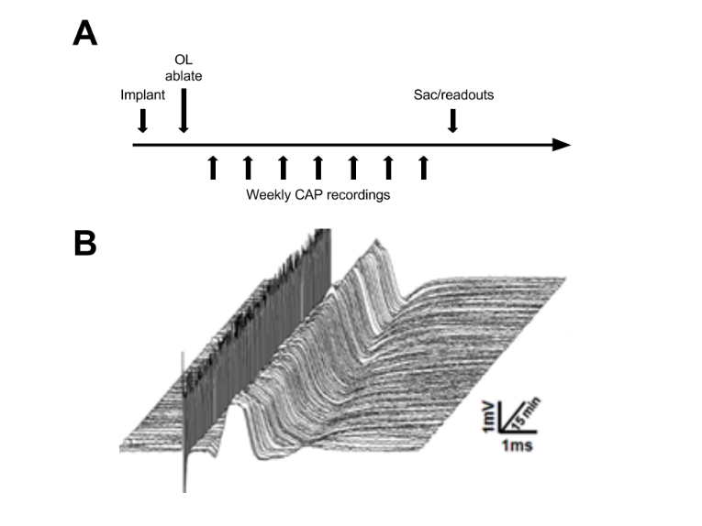To test the hypothesis that axonal conductance regulates myelination in the CNS, I would perform the following:

Figure 1 - CAPs from Sajic 2013

1. Implant stimulating and recording electrodes in lateral corpus callosum to monitor evoked extracellular compound action potentials (CAPs, Fig. 1) across hemispheres (i.e. left stim-right record, vice versa)(Preston, Waxman et al. 1983, Swanson, Krahl et al. 1998, Bando, Takakusaki et al. 2008).
2. Conditionally ablate OLs from one group (OL-) and have a control (WT/OL+). Perform stimulation paradigm in both groups over the course of a month (1 Hz train for an hour daily, don’t want seizures…). Have a stim-minus experimentation control group for each genotype.
3. Quantify readouts such as OPC proliferation, OPC differentiation, myelin thickness by EM, running gait or rotarod, etc (Gibson, Purger et al. 2014).
4. Compare CAP dynamics (ratio of peak to trough evoked potential) between groups and in a recovery-dependent time course (two-way rmANOVA).

**References**

Bando, Y., K. Takakusaki, S. Ito, R. Terayama, M. Kashiwayanagi and S. Yoshida (2008). "Differential changes in axonal conduction following CNS demyelination in two mouse models." Eur J Neurosci **28**(9): 1731-1742.

Barres, B. A. and M. C. Raff (1999). "Axonal control of oligodendrocyte development." J Cell Biol **147**(6): 1123-1128.

Benninger, Y., T. Thurnherr, J. A. Pereira, S. Krause, X. Wu, A. Chrostek-Grashoff, D. Herzog, K. A. Nave, R. J. Franklin, D. Meijer, C. Brakebusch, U. Suter and J. B. Relvas (2007). "Essential and distinct roles for cdc42 and rac1 in the regulation of Schwann cell biology during peripheral nervous system development." J Cell Biol **177**(6): 1051-1061.

Emery, B. and Q. R. Lu (2015). "Transcriptional and Epigenetic Regulation of Oligodendrocyte Development and Myelination in the Central Nervous System." Cold Spring Harb Perspect Biol **7**(9): a020461.

Gibson, E. M., D. Purger, C. W. Mount, A. K. Goldstein, G. L. Lin, L. S. Wood, I. Inema, S. E. Miller, G. Bieri, J. B. Zuchero, B. A. Barres, P. J. Woo, H. Vogel and M. Monje (2014). "Neuronal activity promotes oligodendrogenesis and adaptive myelination in the mammalian brain." Science **344**(6183): 1252304.

Hu, Q. D., B. T. Ang, M. Karsak, W. P. Hu, X. Y. Cui, T. Duka, Y. Takeda, W. Chia, N. Sankar, Y. K. Ng, E. A. Ling, T. Maciag, D. Small, R. Trifonova, R. Kopan, H. Okano, M. Nakafuku, S. Chiba, H. Hirai, J. C. Aster, M. Schachner, C. J. Pallen, K. Watanabe and Z. C. Xiao (2003). "F3/contactin acts as a functional ligand for Notch during oligodendrocyte maturation." Cell **115**(2): 163-175.

Madabhushi, R., F. Gao, A. R. Pfenning, L. Pan, S. Yamakawa, J. Seo, R. Rueda, T. X. Phan, H. Yamakawa, P. C. Pao, R. T. Stott, E. Gjoneska, A. Nott, S. Cho, M. Kellis and L. H. Tsai (2015). "Activity-Induced DNA Breaks Govern the Expression of Neuronal Early-Response Genes." Cell **161**(7): 1592-1605.

Mi, S., R. H. Miller, X. Lee, M. L. Scott, S. Shulag-Morskaya, Z. Shao, J. Chang, G. Thill, M. Levesque, M. Zhang, C. Hession, D. Sah, B. Trapp, Z. He, V. Jung, J. M. McCoy and R. B. Pepinsky (2005). "LINGO-1 negatively regulates myelination by oligodendrocytes." Nat Neurosci **8**(6): 745-751.

Michailov, G. V., M. W. Sereda, B. G. Brinkmann, T. M. Fischer, B. Haug, C. Birchmeier, L. Role, C. Lai, M. H. Schwab and K. A. Nave (2004). "Axonal neuregulin-1 regulates myelin sheath thickness." Science **304**(5671): 700-703.

Preston, R. J., S. G. Waxman and J. D. Kocsis (1983). "Effects of 4-aminopyridine on rapidly and slowly conducting axons of rat corpus callosum." Exp Neurol **79**(3): 808-820.

Salzer, J. L. (2012). "Axonal regulation of Schwann cell ensheathment and myelination." J Peripher Nerv Syst **17 Suppl 3**: 14-19.

Salzer, J. L. (2015). "Schwann cell myelination." Cold Spring Harb Perspect Biol **7**(8): a020529.

Swanson, T. H., S. E. Krahl, Y. Z. Liu, J. A. Drazba and S. A. Rivkees (1998). "Evidence for physiologically active axonal adenosine receptors in the rat corpus callosum." Brain Res **784**(1-2): 188-198.

Thurnherr, T., Y. Benninger, X. Wu, A. Chrostek, S. M. Krause, K. A. Nave, R. J. Franklin, C. Brakebusch, U. Suter and J. B. Relvas (2006). "Cdc42 and Rac1 signaling are both required for and act synergistically in the correct formation of myelin sheaths in the CNS." J Neurosci **26**(40): 10110-10119.

Zuchero, J. B., M. M. Fu, S. A. Sloan, A. Ibrahim, A. Olson, A. Zaremba, J. C. Dugas, S. Wienbar, A. V. Caprariello, C. Kantor, D. Leonoudakis, K. Lariosa-Willingham, G. Kronenberg, K. Gertz, S. H. Soderling, R. H. Miller and B. A. Barres (2015). "CNS myelin wrapping is driven by actin disassembly." Dev Cell **34**(2): 152-167.